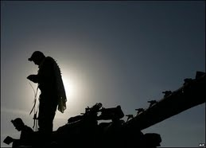
08
Fall
The FJMC’s Annual World Wide Wrap
[Company Address]

Sunday Morning Service Super Sunday

